**Appendix 2**

**RECRUITMENT AND RETENTION ANALYSIS**

1. **ANALYSIS OF APPLICATIONS RECEIVED THROUGH TO INTERVIEW BY ETHNICITY (2017/18)**

|  |  |  |  |  |  |  |  |  |
| --- | --- | --- | --- | --- | --- | --- | --- | --- |
| **City Counci**l | **Applications Received** | | **Interviewed** | | **Appointed** | | **Candidate Withdrew** | |
|  | **Number** | **% Received** | **Number** | **% Group** | **Number** | **% Group** | **Number** | **% Group** |
| White Applicants | 1209 | 78 | 512 | 42 | 89 | 7 | 37 | 3 |
| BAME | 332 | 22 | 119 | 36 | 15 | 5 | 13 | 4 |
| **Total:** | **1541** |  | **631** |  | **104** |  | **50** |  |

|  |  |  |  |  |  |  |  |  |
| --- | --- | --- | --- | --- | --- | --- | --- | --- |
| **Direct Services** | **Applications Received** | | **Interviewed** | | **Appointed** | | **Candidate Withdrew** | |
|  | **Number** | **% Received** | **Number** | **% Group** | **Number** | **% Group** | **Number** | **% Group** |
| White Applicants | 457 | 77 | 320 | 70 | 86 | 19 | 27 | 6 |
| BAME | 134 | 23 | 64 | 48 | 10 | 7 | 5 | 4 |
| **Total:** | **591** |  | **384** |  | **96** |  | **32** |  |

1. **LOCATION OF APPLICANTS**

|  |  |  |  |  |  |  |  |  |  |  |
| --- | --- | --- | --- | --- | --- | --- | --- | --- | --- | --- |
| **Applicants by Postcode (City Council Vacancies)** | | | | | |  |  |  |  |  |
| **Applicant** | **Total** |  |  |  |  |  |  |  |  |  |  |
| Lives inside Central Oxford | 2259 |  |  |  |  |  |  |  |  |  |  |
| Lives outside Central Oxford | 2976 |  |  |  |  |  |  |  |  |  |  |
| **Total:** | **5235** |  |  |  |  |  |  |  |  |  |  |
|  |  |  |  |  |  |  |  |  |  |  |  |
| **Applicants by Postcode (Direct Services Vacancies)** | | | | | |  |  |  |  |  |
| **Applicant** | **Total** |  |  |  |  |  |  |  |  |  |  |
| Lives inside Central Oxford | 1492 |  |  |  |  |  |  |  |  |  |  |
| Lives outside Central Oxford | 1424 |  |  |  |  |  |  |  |  |  |  |
| **Total:** | **2916** |  |  |  |  |  |  |  |  |  |  |
|  |  |  |  |  |  |  |  |  |  |  |  |

1. **LOCATION OF STAFF**

**Oxford City Council**

|  |  |
| --- | --- |
| **Applicant** | **Total** |
| Lives inside Central Oxford | 254 |
| Lives outside Central Oxford | 424 |
| **Total:** | **678** |

**Direct Services**

|  |  |
| --- | --- |
| **Applicant** | **Total** |
| Lives inside Central Oxford | 334 |
| Lives outside Central Oxford | 317 |
| **Total:** | **651** |

|  |  |  |  |  |  |  |  |  |  |  |  |
| --- | --- | --- | --- | --- | --- | --- | --- | --- | --- | --- | --- |
| 1. **STAFF TURNOVER** |  |  |  |  |  |  |  |  |  |  |  |

**Oxford City Council**

|  |  |  |
| --- | --- | --- |
| **Ethnicity** | **Number** | **%** |
| BAME | 7 | 8.5% |
| White | 64 | 78% |
| Not Specified | 11 | 13.5% |
| **Total:** | **82** |  |
| **Average Staff Turnover** |  | **12.1%** |

**Oxford Direct Services**

|  |  |  |
| --- | --- | --- |
| **Ethnicity** | **Number** | **%** |
| BAME | 5 | 7.3 |
| White | 54 | 78.3 |
| Not Specified | 10 | 14.4 |
| **Total:** | **69** |  |
| **Average Staff Turnover** |  | **10.6%** |

1. **ECONOMICALLY ACTIVE BAME & WHITE OTHER GROUPS (OX1 to OX4)**

|  |  |  |
| --- | --- | --- |
|  | **% of economically active who are BME** | **% of economically active who are White Other** |
| **Oxford City wards in OX1** | 17% | 19% |
| **Oxford City wards in OX2** | 11% | 19% |
| **Oxford City wards in OX3** | 20% | 13% |
| **Oxford City wards in OX4** | 21% | 14% |
| **Grand Total** | 19% | 15% |

|  |  |  |  |  |  |  |  |
| --- | --- | --- | --- | --- | --- | --- | --- |
| 1. **ANALYSIS OF COMMUNITY SERVICES RECRUITMENT SCHEMES 2017/18** | | | |  |  |  |  |
|  |  |  |  |  |  |  |  |
| **Applicants from BAME Groups** |  |  |  |  |  |  |  |
|  |  |  |  |  | **% Applic'ns Received** | |  |
| **Requisition Ref** | **Appl'ns Rec'd** | **Interviewed** | **Appointed** | **Withdrew** | **Interviewed** | **Appointed** | **Withdrew** |
| 001314 | 8 | 4 | 1 | 0 | 50% | 12% | 0% |
| 001345 | 5 | 3 | 0 | 0 | 60% | 0% | 0% |
| **Totals:** | **13** | **7** | **1** | **0** |  |  |  |
|  |  | **58%** | **8%** | **0%** |  |  |  |
|  |  |  |  |  |  |  |  |
| **Applicants from White Groups** |  |  |  |  |  |  |  |
|  |  |  |  |  | **% Applic'ns Received** | | |
| **Requisition Ref** | **Appl'ns Rec'd** | **Interviewed** | **Appointed** | **Withdrew** | **Interviewed** | **Appointed** | **Withdrew** |
| 001314 | 5 | 1 | 0 | 0 | 20% | 0% | 0% |
| 001345 | 16 | 9 | 1 | 0 | 56% | 6% | 0% |
| **Totals:** | **21** | **10** | **1** | **0** |  |  |  |
|  |  | **48%** | **5%** | **0%** |  |  |  |
|  |  |  |  |  |  |  |  |

**Note: 36 schemes reached appointment stage**

|  |  |  |  |  |  |  |  |
| --- | --- | --- | --- | --- | --- | --- | --- |
| 1. **ANALYSIS OF HOUSING SERVICES RECRUITMENT SCHEMES 2017/18** | | | |  |  |  |  |
|  |  |  |  |  |  |  |  |
| **Applicants from BAME Groups** |  |  |  |  |  |  |  |
|  |  |  |  |  | **% Applic'ns Received** | |  |
| **Requisition Ref** | **Appl'ns Rec'd** | **Interviewed** | **Appointed** | **Withdrew** | **Interviewed** | **Appointed** | **Withdrew** |
| 001351 | 1 | 1 | 0 | 0 | 100% | 0% | 0% |
| 001346 | 5 | 3 | 0 | 0 | 60% | 0% | 0% |
| **Totals:** | **6** | **4** | **0** | **0** |  |  |  |
|  |  | **66%** | **0%** | **0%** |  |  |  |
|  |  |  |  |  |  |  |  |
| **Applicants from White Groups** |  |  |  |  |  |  |  |
|  |  |  |  |  |  | **% Applic'ns Received** | |
| **Requisition Ref** | **Appl'ns Rec'd** | **Interviewed** | **Appointed** | **Withdrew** | **Interviewed** | **Appointed** | **Withdrew** |
| 001351 | 3 | 3 | 0 | 0 | 100% | 0% | 0% |
| 001346 | 5 | 2 | 0 | 0 | 40% | 0% | 0% |
| **Totals:** | **8** | **5** | **0** | **0** |  |  |  |
|  |  | **63%** | **0%** | **0%** |  |  |  |
|  |  |  |  |  |  |  |  |

**Note: 16 schemes reached appointment stage**

1. **COMMUNITY SERVICES: SAMPLE RECRUITMENT SCHEME ANALYSIS**

|  |  |  |  |  |  |  |  |  |
| --- | --- | --- | --- | --- | --- | --- | --- | --- |
| **Service**  **Area** | **Requisition**  **Reference** | **Job title** | **Grade** | **Hours** | **Internal/**  **External** | **Advertised** | **Shortlisting receipt** | **Interview details** |
| Community Services | 001314 | VAWG Strategic Officer | 7 | 37 | External | OCC website; Distribution email; Universal jobmatch; Auto post to Indeed | 06/02/2018 | 10 minute presentation:  This post will sit in Oxford City Council but will be overseen by a Thames Valley BAMER Board and supported by 6 BAMER support workers who will be based in local specialist services.  We would like you to give a 10 minute presentation outlining your work plan, titled ‘My First Three Months in Post’.  45 minute competency interview and completion of psychometric questions.  This will enable essential criteria on JD to be assessed for the role:  technical knowledge, investigative skills. Additionally it will demonstrate organisational skills and ability to meet priorities against key deadlines.  45 minute interview will consist of 8 - 10 questions, incorporating environmental crime and Anti-social behaviour and questions to establish partnership working knowledge, team working and alignment with corporate values and behaviours. |
| Community Services | 001345 | Performance and Impact Officer | 6 | 37 | External | OCC website; Distribution email; Universal jobmatch; Auto post to Indeed | 26/03/2018 | Your interview will consist of a test lasting 35 minutes and you will be notified of the topic on the day. The test will include paper and computer based elements.  This will be followed by a question and answer session lasting approximately 55 minutes. |

1. **HOUSING SERVICES: SAMPLE RECRUITMENT SCHEME ANALYSIS**

|  |  |  |  |  |  |  |  |  |
| --- | --- | --- | --- | --- | --- | --- | --- | --- |
| **Service**  **Area** | **Requisition**  **Reference** | **Job title** | **Grade** | **Hours** | **Internal/**  **External** | **Advertised** | **Shortlisting receipt** | **Interview details** |
| Housing | 001351 | Tenancy Management Support Officer | 5 | 37 | Internal | OCC website only | 04/04/2018 | Your assessment will last 45 minutes and will consist of a 30 minute face to face interview followed by a 15 minute computer based test. |
| Housing | 001346 | Energy Advice Officer | 6 | 37 | External | OCC website; Distribution email; Universal jobmatch; Auto post to Indeed | 20/03/2018 | Your assessment will consist of a 30 minute job related test followed by a 1 hour panel interview. |

1. **OXFORD POPULATION DATA: HIGHEST QUALIFICATION HELD**

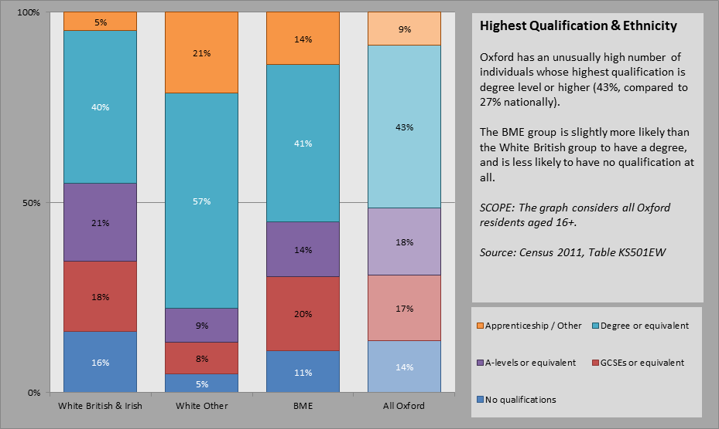

This bar chart indicates that there is a well-qualified local labour market, which suggests that there should be a consistent level of applications from all ethnic groups [i.e. BAME and White] across most of the roles advertised by the Council, with the exception of jobs that require a specific technical or professional qualification as an essential criterion in the person specification for the job.